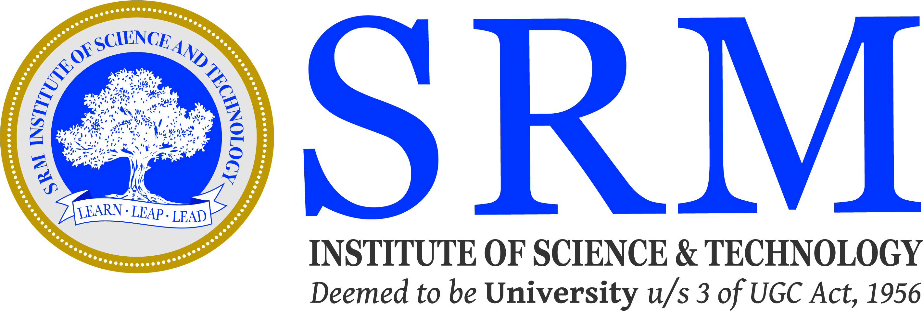
SRM INSTITUTE OF SCIENCE AND TECHNOLOGY
(Deemed to be University U/s 3 of UGC Act, 1956)

Pre Ph.D Presentation Minutes

The Pre-Ph.D meeting of the Research Scholar Mr./Mrs.__________________ (Full Time/ Part Time - Int / Ext) Reg.No._________________was held on_________________at ________AM/PM in the Department of __________________________, SRM Institute of Science and Technology, Kattankulathur.
The research scholar presented his/her Pre – Ph.D on “_________________________________________”. The professors, faculty members, and research scholars raised their queries and provided valuable feedback in the research field.
The attendance of the audience in the Pre-Ph.D presentation is enclosed.

Signature of Signature of Supervisor
Joint Supervisor

Signature of DRCC Signature of Head of
Chairperson Department

